ST10225619

Mubasher Hussain

ADDB6311

Practicum

24/06/2024

----------------------------------------------------------------------------------------------------------

GitHub Link to repository:

https://github.com/mubasherhu/ADDB6311-Practicum-Exam.git

Question 1   
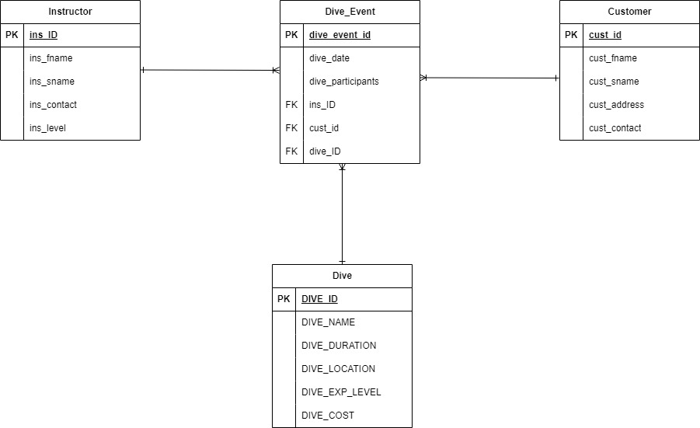

CREATE TABLE INSTRUCTOR (

ins_ID VARCHAR2(10) NOT NULL,

ins_fname VARCHAR2(50) NOT NULL,

ins_sname VARCHAR2(50) NOT NULL,

ins_contact VARCHAR2(15) NOT NULL,

ins_level NUMBER NOT NULL,

CONSTRAINT INSTRUCTOR_PK PRIMARY KEY (ins_ID)

);

CREATE TABLE CUSTOMER (

cust_id VARCHAR2(10) NOT NULL,

cust_fname VARCHAR2(50) NOT NULL,

cust_sname VARCHAR2(50) NOT NULL,

cust_address VARCHAR2(100) NOT NULL,

cust_contact VARCHAR2(15) NOT NULL,

CONSTRAINT CUSTOMER_PK PRIMARY KEY (cust_id)

);

CREATE TABLE DIVE (

DIVE_ID NUMBER NOT NULL,

DIVE_NAME VARCHAR2(50) NOT NULL,

DIVE_DURATION VARCHAR2(20),

DIVE_LOCATION VARCHAR2(50),

DIVE_EXP_LEVEL NUMBER,

DIVE_COST NUMBER,

CONSTRAINT DIVE_PK PRIMARY KEY (DIVE_ID)

);

CREATE TABLE DIVE_EVENT (

dive_event_id VARCHAR2(10) NOT NULL,

dive_date DATE NOT NULL,

dive_participants NUMBER NOT NULL,

ins_ID VARCHAR2(10) NOT NULL,

cust_id VARCHAR2(10) NOT NULL,

dive_ID NUMBER NOT NULL,

CONSTRAINT DIVE_EVENT_PK PRIMARY KEY (dive_event_id),

CONSTRAINT DIVE_EVENT_FK_INS_ID FOREIGN KEY (ins_ID) REFERENCES INSTRUCTOR(ins_ID),

CONSTRAINT DIVE_EVENT_FK_CUST_ID FOREIGN KEY (cust_id) REFERENCES CUSTOMER(cust_id),

CONSTRAINT DIVE_EVENT_FK_DIVE_ID FOREIGN KEY (dive_ID) REFERENCES DIVE(dive_ID)

);

INSERT INTO INSTRUCTOR (ins_ID, ins_fname, ins_sname, ins_contact, ins_level) VALUES

('101', 'James', 'Willis', '0843569851', 7);

INSERT INTO INSTRUCTOR (ins_ID, ins_fname, ins_sname, ins_contact, ins_level) VALUES

('102', 'Sam', 'Wait', '0763698521', 2);

INSERT INTO INSTRUCTOR (ins_ID, ins_fname, ins_sname, ins_contact, ins_level) VALUES

('103', 'Sally', 'Gumede', '0786598521', 8);

INSERT INTO INSTRUCTOR (ins_ID, ins_fname, ins_sname, ins_contact, ins_level) VALUES

('104', 'Bob', 'Du Preez', '0796369857', 3);

INSERT INTO INSTRUCTOR (ins_ID, ins_fname, ins_sname, ins_contact, ins_level) VALUES

('105', 'Simon', 'Jones', '0826598741', 9);

INSERT INTO CUSTOMER (cust_id, cust_fname, cust_sname, cust_address, cust_contact) VALUES

('C115', 'Heinrich', 'Willis', '3 Main Road', '0821253659');

INSERT INTO CUSTOMER (cust_id, cust_fname, cust_sname, cust_address, cust_contact) VALUES

('C116', 'David', 'Watson', '13 Cape Road', '0769658547');

INSERT INTO CUSTOMER (cust_id, cust_fname, cust_sname, cust_address, cust_contact) VALUES

('C117', 'Waldo', 'Smith', '3 Mountain Road', '0863256574');

INSERT INTO CUSTOMER (cust_id, cust_fname, cust_sname, cust_address, cust_contact) VALUES

('C118', 'Alex', 'Hanson', '8 Circle Road', '0762356587');

INSERT INTO CUSTOMER (cust_id, cust_fname, cust_sname, cust_address, cust_contact) VALUES

('C119', 'Kuhle', 'Bitterhout', '15 Main Road', '0821235258');

INSERT INTO DIVE (DIVE_ID, DIVE_NAME, DIVE_DURATION, DIVE_LOCATION, DIVE_EXP_LEVEL, DIVE_COST) VALUES

(550, 'Shark Dive', '3 hours', 'Shark Point', 8, 500);

INSERT INTO DIVE (DIVE_ID, DIVE_NAME, DIVE_DURATION, DIVE_LOCATION, DIVE_EXP_LEVEL, DIVE_COST) VALUES

(551, 'Coral Dive', '1 hour', 'Break Point', 7, 300);

INSERT INTO DIVE (DIVE_ID, DIVE_NAME, DIVE_DURATION, DIVE_LOCATION, DIVE_EXP_LEVEL, DIVE_COST) VALUES

(552, 'Wave Cresect', '2 hours', 'Ship wreck ally', 3, 800);

INSERT INTO DIVE (DIVE_ID, DIVE_NAME, DIVE_DURATION, DIVE_LOCATION, DIVE_EXP_LEVEL, DIVE_COST) VALUES

(553, 'Underwater Adventure', '1 hour', 'Coral ally', 2, 250);

INSERT INTO DIVE (DIVE_ID, DIVE_NAME, DIVE_DURATION, DIVE_LOCATION, DIVE_EXP_LEVEL, DIVE_COST) VALUES

(554, 'Underwater Adventure', '3 hours', 'Sandy Beach', 3, 750);

INSERT INTO DIVE (DIVE_ID, DIVE_NAME, DIVE_DURATION, DIVE_LOCATION, DIVE_EXP_LEVEL, DIVE_COST) VALUES

(555, 'Deep Blue Ocean', '30 Minutes', 'Lazy Waves', 2, 120);

INSERT INTO DIVE (DIVE_ID, DIVE_NAME, DIVE_DURATION, DIVE_LOCATION, DIVE_EXP_LEVEL, DIVE_COST) VALUES

(556, 'Rough Seas', '1 hour', 'Pipe', 9, 700);

INSERT INTO DIVE (DIVE_ID, DIVE_NAME, DIVE_DURATION, DIVE_LOCATION, DIVE_EXP_LEVEL, DIVE_COST) VALUES

(557, 'White Water', '2 hours', 'Drifts', 5, 200);

INSERT INTO DIVE (DIVE_ID, DIVE_NAME, DIVE_DURATION, DIVE_LOCATION, DIVE_EXP_LEVEL, DIVE_COST) VALUES

(558, 'Current Adventure', '2 hours', 'Rock Lands', 3, 150);

-- Inserting into DIVE_EVENT

INSERT INTO DIVE_EVENT (dive_event_id, dive_date, dive_participants, ins_ID, cust_id, dive_ID)

VALUES ('de_101', TO_DATE('2017-07-15', 'YYYY-MM-DD'), 5, '103', 'C115', 558);

INSERT INTO DIVE_EVENT (dive_event_id, dive_date, dive_participants, ins_ID, cust_id, dive_ID)

VALUES ('de_102', TO_DATE('2017-07-16', 'YYYY-MM-DD'), 7, '102', 'C117', 555);

INSERT INTO DIVE_EVENT (dive_event_id, dive_date, dive_participants, ins_ID, cust_id, dive_ID)

VALUES ('de_103', TO_DATE('2017-07-18', 'YYYY-MM-DD'), 8, '104', 'C118', 552);

INSERT INTO DIVE_EVENT (dive_event_id, dive_date, dive_participants, ins_ID, cust_id, dive_ID)

VALUES ('de_104', TO_DATE('2017-07-19', 'YYYY-MM-DD'), 3, '101', 'C119', 551);

INSERT INTO DIVE_EVENT (dive_event_id, dive_date, dive_participants, ins_ID, cust_id, dive_ID)

VALUES ('de_105', TO_DATE('2017-07-21', 'YYYY-MM-DD'), 5, '104', 'C115', 558);

INSERT INTO DIVE_EVENT (dive_event_id, dive_date, dive_participants, ins_ID, cust_id, dive_ID)

VALUES ('de_106', TO_DATE('2017-07-22', 'YYYY-MM-DD'), 8, '105', 'C116', 556);

INSERT INTO DIVE_EVENT (dive_event_id, dive_date, dive_participants, ins_ID, cust_id, dive_ID)

VALUES ('de_107', TO_DATE('2017-07-25', 'YYYY-MM-DD'), 10, '105', 'C115', 554);

INSERT INTO DIVE_EVENT (dive_event_id, dive_date, dive_participants, ins_ID, cust_id, dive_ID)

VALUES ('de_108', TO_DATE('2017-07-27', 'YYYY-MM-DD'), 5, '101', 'C118', 552);

INSERT INTO DIVE_EVENT (dive_event_id, dive_date, dive_participants, ins_ID, cust_id, dive_ID)

VALUES ('de_109', TO_DATE('2017-07-28', 'YYYY-MM-DD'), 3, '102', 'C119', 553);

Question 2

--Question 2

--step 1 Craeting Roles

-- Create Administrator Role

CREATE ROLE C##admin_role;

-- Create General User Role

CREATE ROLE C##user_role;

-- Step 2: Assign Privileges

-- Grant Administrator Privileges

-- Administrator has full privileges on all tables

GRANT ALL PRIVILEGES ON INSTRUCTOR TO C##admin_role;

GRANT ALL PRIVILEGES ON CUSTOMER TO C##admin_role;

GRANT ALL PRIVILEGES ON DIVE TO C##admin_role;

GRANT ALL PRIVILEGES ON DIVE_EVENT TO C##admin_role;

-- General User Privileges

-- General user has SELECT privileges and can perform INSERT operations

GRANT SELECT, INSERT ON INSTRUCTOR TO C##user_role;

GRANT SELECT, INSERT ON CUSTOMER TO C##user_role;

GRANT SELECT, INSERT ON DIVE TO C##user_role;

GRANT SELECT, INSERT ON DIVE_EVENT TO C##user_role;

-- Step 3: Create Users and Assign Roles

-- Create Administrator User

CREATE USER C##admin_user IDENTIFIED BY admin_password;

GRANT C##admin_role TO C##admin_user;

-- Create General User

CREATE USER C##general_user IDENTIFIED BY user_password;

GRANT C##user_role TO C##general_user;

-- Optional: Grant Connect Privilege (allows the user to connect to the database)

GRANT CONNECT TO C##admin_user;

GRANT CONNECT TO C##general_user;

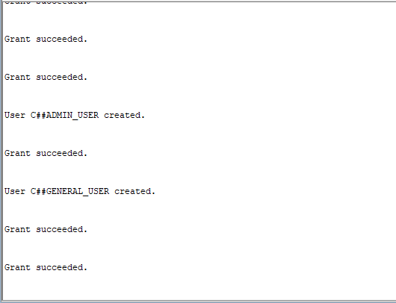

Question 3

--Question 3

SELECT

i.ins_fname || ' ' || i.ins_sname AS instructor_name,

c.cust_fname || ' ' || c.cust_sname AS customer_full_name,

d.DIVE_LOCATION,

de.dive_participants

FROM

DIVE_EVENT de

JOIN

INSTRUCTOR i ON de.ins_ID = i.ins_ID

JOIN

CUSTOMER c ON de.cust_id = c.cust_id

JOIN

DIVE d ON de.dive_ID = d.DIVE_ID

WHERE

de.dive_participants BETWEEN 8 AND 10;

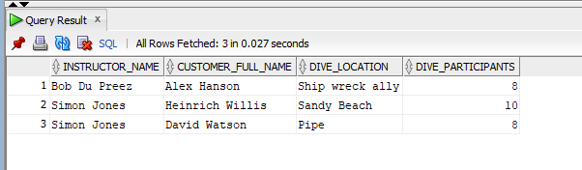

Question 4

SET SERVEROUTPUT ON;

DECLARE

-- Cursor to fetch dive name, dive date, and number of participants for events with 10 or more participants

CURSOR dive_event_cursor IS

SELECT

d.DIVE_NAME,

de.dive_date,

de.dive_participants

FROM

DIVE_EVENT de

JOIN

DIVE d ON de.dive_ID = d.DIVE_ID

WHERE

de.dive_participants >= 10;

-- Record type to hold the cursor results

dive_event_record dive_event_cursor%ROWTYPE;

BEGIN

-- Open the cursor

OPEN dive_event_cursor;

-- Loop through the cursor and display the results

LOOP

FETCH dive_event_cursor INTO dive_event_record;

EXIT WHEN dive_event_cursor%NOTFOUND;

DBMS_OUTPUT.PUT_LINE('Dive Name: ' || dive_event_record.DIVE_NAME);

DBMS_OUTPUT.PUT_LINE('Allocated Date: ' || TO_CHAR(dive_event_record.dive_date, 'YYYY-MM-DD'));

DBMS_OUTPUT.PUT_LINE('Number of Participants: ' || dive_event_record.dive_participants);

DBMS_OUTPUT.PUT_LINE('---------------------------');

END LOOP;

-- Close the cursor

CLOSE dive_event_cursor;

END;

/

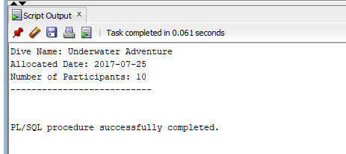

QUESTION 5

SET SERVEROUTPUT ON;

DECLARE

-- Cursor to fetch customer full name, dive event name, dive participants, and dive cost for events costing over R500

CURSOR dive_event_cursor IS

SELECT

c.cust_fname || ' ' || c.cust_sname AS customer_full_name,

d.DIVE_NAME,

de.dive_participants,

d.DIVE_COST

FROM

DIVE_EVENT de

JOIN

CUSTOMER c ON de.cust_id = c.cust_id

JOIN

DIVE d ON de.dive_ID = d.DIVE_ID

WHERE

d.DIVE_COST > 500;

-- Record type to hold the cursor results

dive_event_record dive_event_cursor%ROWTYPE;

-- Variable to store the number of instructors required

num_instructors NUMBER;

BEGIN

-- Open the cursor

OPEN dive_event_cursor;

-- Loop through the cursor and display the results

LOOP

FETCH dive_event_cursor INTO dive_event_record;

EXIT WHEN dive_event_cursor%NOTFOUND;

-- Determine the number of instructors required based on the number of participants

IF dive_event_record.dive_participants <= 4 THEN

num_instructors := 1;

ELSIF dive_event_record.dive_participants BETWEEN 5 AND 7 THEN

num_instructors := 2;

ELSE

num_instructors := 3;

END IF;

-- Display the result

DBMS_OUTPUT.PUT_LINE('Customer Full Name: ' || dive_event_record.customer_full_name);

DBMS_OUTPUT.PUT_LINE('Dive Event Name: ' || dive_event_record.DIVE_NAME);

DBMS_OUTPUT.PUT_LINE('Dive Participants: ' || dive_event_record.dive_participants);

DBMS_OUTPUT.PUT_LINE('Number of Instructors Required: ' || num_instructors);

DBMS_OUTPUT.PUT_LINE('---------------------------');

END LOOP;

-- Display cursor attributes

DBMS_OUTPUT.PUT_LINE('Total Rows Processed: ' || dive_event_cursor%ROWCOUNT);

IF dive_event_cursor%FOUND THEN

DBMS_OUTPUT.PUT_LINE('Last Row Fetched: ' || dive_event_cursor%ROWCOUNT);

ELSE

DBMS_OUTPUT.PUT_LINE('No rows found.');

END IF;

-- Close the cursor

CLOSE dive_event_cursor;

END;

/

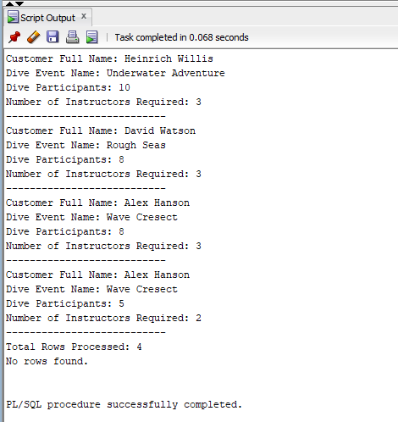

Question 6

SET SERVEROUTPUT ON

CREATE OR REPLACE VIEW Vw_Dive_Evnt AS

SELECT

de.ins_ID,

de.cust_id,

c.cust_address,

d.DIVE_DURATION

FROM

DIVE_EVENT de

JOIN

CUSTOMER c ON de.cust_id = c.cust_id

JOIN

DIVE d ON de.dive_ID = d.DIVE_ID

WHERE

de.dive_date < TO_DATE('2017-07-19', 'YYYY-MM-DD');

SELECT * FROM Vw_Dive_Evnt;

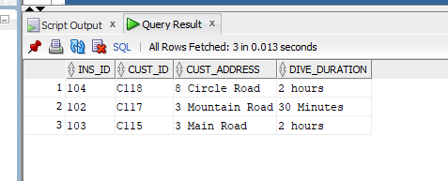

Question 7

CREATE OR REPLACE TRIGGER New_Dive_Even

BEFORE INSERT OR UPDATE ON DIVE_EVENT

FOR EACH ROW

BEGIN

IF :NEW.dive_participants <= 0 THEN

RAISE_APPLICATION_ERROR(-20001, 'Number of participants must be greater than 0.');

ELSIF :NEW.dive_participants > 20 THEN

RAISE_APPLICATION_ERROR(-20002, 'Number of participants must be 20 or less.');

END IF;

END;

/

-- Testing with 0 participants (should raise an error)

BEGIN

INSERT INTO DIVE_EVENT (dive_event_id, dive_date, dive_participants, ins_ID, cust_id, dive_ID)

VALUES ('test_001', TO_DATE('2023-06-01', 'YYYY-MM-DD'), 0, '101', 'C115', 550);

EXCEPTION

WHEN OTHERS THEN

DBMS_OUTPUT.PUT_LINE(SQLERRM);

END;

/

-- Testing with less than 0 participants (should raise an error)

BEGIN

INSERT INTO DIVE_EVENT (dive_event_id, dive_date, dive_participants, ins_ID, cust_id, dive_ID)

VALUES ('test_002', TO_DATE('2023-06-01', 'YYYY-MM-DD'), -5, '102', 'C116', 551);

EXCEPTION

WHEN OTHERS THEN

DBMS_OUTPUT.PUT_LINE(SQLERRM);

END;

/

-- Testing with more than 20 participants (should raise an error)

BEGIN

INSERT INTO DIVE_EVENT (dive_event_id, dive_date, dive_participants, ins_ID, cust_id, dive_ID)

VALUES ('test_003', TO_DATE('2023-06-01', 'YYYY-MM-DD'), 25, '103', 'C117', 552);

EXCEPTION

WHEN OTHERS THEN

DBMS_OUTPUT.PUT_LINE(SQLERRM);

END;

/

-- Testing with valid number of participants (should succeed)

BEGIN

INSERT INTO DIVE_EVENT (dive_event_id, dive_date, dive_participants, ins_ID, cust_id, dive_ID)

VALUES ('test_004', TO_DATE('2023-06-01', 'YYYY-MM-DD'), 10, '104', 'C118', 553);

DBMS_OUTPUT.PUT_LINE('Insert successful');

EXCEPTION

WHEN OTHERS THEN

DBMS_OUTPUT.PUT_LINE(SQLERRM);

END;

/

-- Testing with valid number of participants (should succeed)

BEGIN

INSERT INTO DIVE_EVENT (dive_event_id, dive_date, dive_participants, ins_ID, cust_id, dive_ID)

VALUES ('test_004', TO_DATE('2023-06-01', 'YYYY-MM-DD'), 10, '104', 'C118', 553);

DBMS_OUTPUT.PUT_LINE('Insert successful');

EXCEPTION

WHEN OTHERS THEN

DBMS_OUTPUT.PUT_LINE(SQLERRM);

END;

/

SET SERVEROUTPUT ON;

test updates

BEGIN

UPDATE DIVE_EVENT

SET dive_participants = 0

WHERE dive_event_id = 'test_004';

EXCEPTION

WHEN OTHERS THEN

DBMS_OUTPUT.PUT_LINE(SQLERRM);

END;

/

BEGIN

UPDATE DIVE_EVENT

SET dive_participants = 25

WHERE dive_event_id = 'test_004';

EXCEPTION

WHEN OTHERS THEN

DBMS_OUTPUT.PUT_LINE(SQLERRM);

END;

/

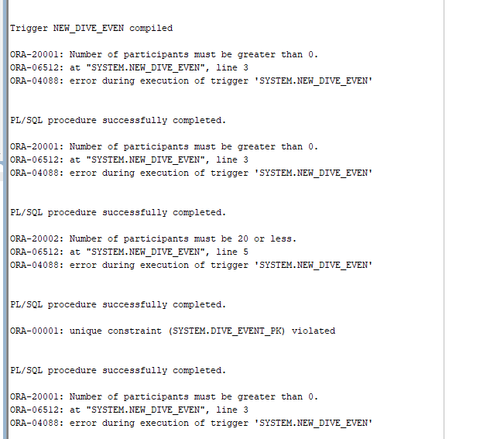

Question 8

CREATE OR REPLACE PROCEDURE sp_Customer_Details (

p_cust_id IN VARCHAR2,

p_dive_date IN DATE

)

IS

-- Variables to hold customer and dive names

v_cust_name VARCHAR2(100);

v_dive_name VARCHAR2(50);

BEGIN

-- Select the customer and dive names for the given customer ID and dive date

SELECT c.cust_fname || ' ' || c.cust_sname, d.DIVE_NAME

INTO v_cust_name, v_dive_name

FROM DIVE_EVENT de

JOIN CUSTOMER c ON de.cust_id = c.cust_id

JOIN DIVE d ON de.dive_ID = d.DIVE_ID

WHERE de.cust_id = p_cust_id AND de.dive_date = p_dive_date;

-- Display the results

DBMS_OUTPUT.PUT_LINE('Customer Name: ' || v_cust_name);

DBMS_OUTPUT.PUT_LINE('Dive Name: ' || v_dive_name);

EXCEPTION

WHEN NO_DATA_FOUND THEN

DBMS_OUTPUT.PUT_LINE('No customer found for the given ID and dive date.');

WHEN OTHERS THEN

DBMS_OUTPUT.PUT_LINE('An error occurred: ' || SQLERRM);

END;

/

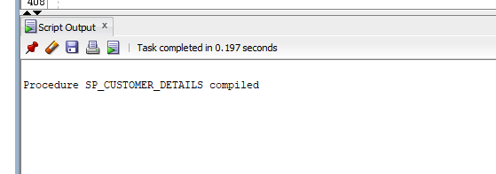

SET SERVEROUTPUT ON;

-- Execute the procedure with a valid customer ID and dive date

BEGIN

sp_Customer_Details('C115', TO_DATE('2017-07-15', 'YYYY-MM-DD'));

END;

/

-- Execute the procedure with an invalid customer ID

BEGIN

sp_Customer_Details('INVALID_ID', TO_DATE('2017-07-15', 'YYYY-MM-DD'));

END;

/

-- Execute the procedure with a valid customer ID but invalid dive date

BEGIN

sp_Customer_Details('C115', TO_DATE('2019-01-01', 'YYYY-MM-DD'));

END;

/

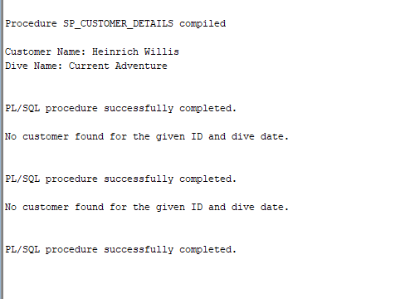

Question 9

CREATE OR REPLACE FUNCTION calculate_dive_cost (

p_dive_event_id IN VARCHAR2

) RETURN NUMBER

IS

-- Declare variables to hold the number of participants and cost per participant

v_participants NUMBER;

v_cost_per_participant NUMBER;

v_total_cost NUMBER;

BEGIN

-- Objective: Fetch the number of participants and cost per participant for the given dive event ID

-- Fetch the number of participants from the DIVE_EVENT table

SELECT dive_participants

INTO v_participants

FROM DIVE_EVENT

WHERE dive_event_id = p_dive_event_id;

-- Fetch the cost per participant from the DIVE table via the DIVE_EVENT table

SELECT d.DIVE_COST

INTO v_cost_per_participant

FROM DIVE d

JOIN DIVE_EVENT de ON d.DIVE_ID = de.dive_ID

WHERE de.dive_event_id = p_dive_event_id;

-- Perform the calculation: total cost = number of participants * cost per participant

v_total_cost := v_participants * v_cost_per_participant;

-- Return the total cost

RETURN v_total_cost;

EXCEPTION

-- Handle exceptions

-- If no data is found for the given dive event ID, return 0 and display an error message

WHEN NO_DATA_FOUND THEN

DBMS_OUTPUT.PUT_LINE('No data found for the given dive event ID: ' || p_dive_event_id);

RETURN 0;

-- Handle any other exceptions

WHEN OTHERS THEN

DBMS_OUTPUT.PUT_LINE('An error occurred: ' || SQLERRM);

RETURN 0;

END calculate_dive_cost;

/  
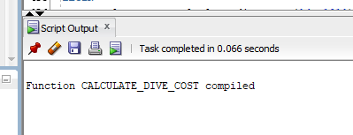

-- Ensure server output is enabled to see the DBMS_OUTPUT.PUT_LINE messages

SET SERVEROUTPUT ON;

-- Test the function with a valid dive event ID

DECLARE

v_total_cost NUMBER;

BEGIN

v_total_cost := calculate_dive_cost('de_101');

DBMS_OUTPUT.PUT_LINE('Total Cost for Dive Event de_101: ' || v_total_cost);

END;

/

-- Test the function with an invalid dive event ID

DECLARE

v_total_cost NUMBER;

BEGIN

v_total_cost := calculate_dive_cost('invalid_id');

DBMS_OUTPUT.PUT_LINE('Total Cost for Dive Event invalid_id: ' || v_total_cost);

END;

/

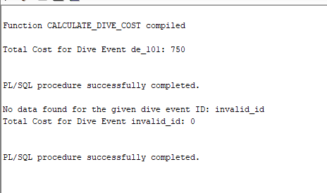

Question 10

Gui

I decided to make use of C# in Visual Studio design the console Gui

Console.WriteLine("----------------------------------------------\n");

Console.WriteLine( "IT Gear Dealer\n");

Console.WriteLine("----------------------------------------------\n");

Console.WriteLine("Select the required Printout:\n" +

"1)Customer Details Report\n" +

"2)Dive Adjustments\n" +

"Enter report selection:\n");

int userChoice = int.Parse( Console.ReadLine());

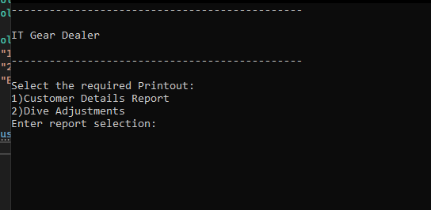

Question 11

